Kien Duc Vu Homework 5

**Problem 1:**

X ~ Gamma(a1, b1)

Y ~ Gamma(a2, b2)

a1, b1, a2, b2 ~ Gamma(0.001,0.001)

mean1 <- (a1/b1)

mean2 <- (a2/b2)

diff <- (mean2 -mean1)

Posterior distribution for difference in mean blood percentages for the 2 procedures are N(2.45, 0.7679)

95% credible set for the difference is [0.9526, 3.978], thus it does not contain 0.

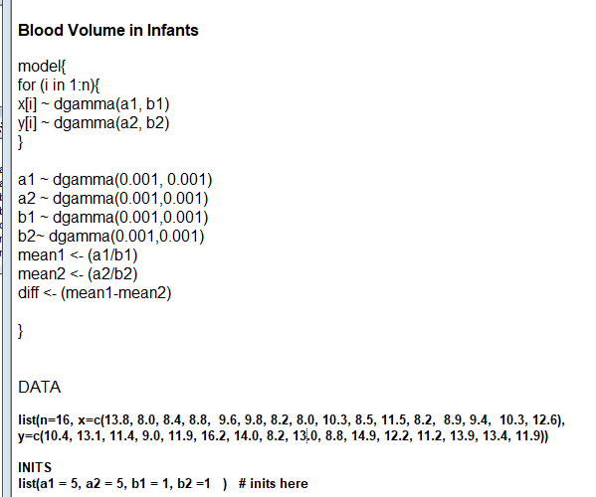

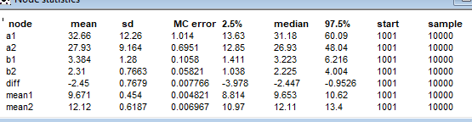

**Problem 2:**

Arctic ~ Bern(p[i])

Logit(p) = beta[1] + beta[2] * gender + beta[3] * x3 +beta[4] * x7

Beta[j] ~ N(0, 0.01)

Probability that a female wolf with measures x 3 = 5.28 and x7 = 1.78 comes from Arctic habitat is 49.93%

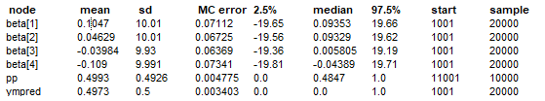

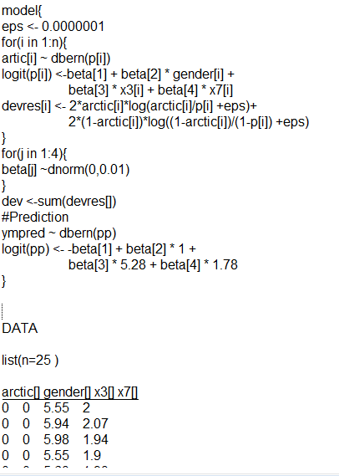

**Problem 3:**

y ~ Poiss(lambda)

lambda <- exp(beta[1] + beta[2] *x)

beta ~ N(0, 0.001)

After 1000 burn-out and 4000 simulations

Beta = [ -2.816, 0.6715]

Average number of nuclei for 3.5G dose is mean = 0.6232

95% credible set =[ 0, 2]

